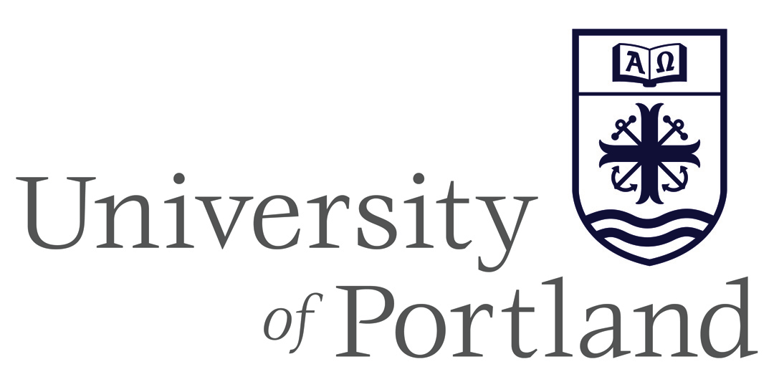

Employee Exit Process

Office of HUMAN RESOURCES |  | 5000 North Willamette Blvd.  Portland, OR 97203-5798 |  | T 503.943.8784  F 503.943.7433 |  | www.up.edu/

For Use By Managers/Office Administrators
** This process is intended for those employees leaving the University. If an employee is transferring to a new department, do not complete the termination notice form. **

- Dean/Chair/ Director should call Human Resources to discuss any separation decisions before the final work day is determined. As an Oregon employer, we are expected to have a final pay check ready for delivery on the last day worked. To facilitate this, HR may need to confer with the employee in advance of the last day to discuss final pay issues.

- Upon notice of a future termination, the manager or designated staff member completes the online Termination Form, which informs all relevant University departments of the separation and date of the last day worked (Public Safety, IT Helpdesk, etc). If the employee is resigning, please forward a copy of the resignation letter by email to hr@up.edu.

- Manager or designated staff member contacts Human Resources at hr@up.edu to schedule the employee’s Exit Interview. Exit Interviews are intended to discuss separation items with employees, like final pay and benefits, and to give the employee an opportunity to share feedback about their employment experience at UP. They should be scheduled on the employee’s last day with his/her manager and HR (allow for 30 minutes).

- On Employee’s Last Day - Manager or designated staff member collects the following items, if applicable:

  - Keys – Return to Physical Plant
  - University ID Card – Return to Public Safety
  - P-Card – Return to Finance c/o Theresa Knott
  - Computer Equipment (Laptop, BB/Cell Phone, etc) – Call Help Desk
  - Parking Pass – Return to Public Safety

