Enrichment Activity guide:
- Organizations to Follow for Learning and Action
- Walking/Bike Tours
- Podcasts
- Documentaries and Videos
- Theater
Reflection Questions
We invite you to continue to use these questions to reflect individually and/or with others after any of these opportunities.
- What is one new thing you learned today?
- How were your assumptions and stereotypes challenged?
- Where did you find hope today? When did you experience joy?
- What did you learn about yourself today?
- What was the high/low moment of today?
- What did you learn about community? Solidarity? Social justice?
- How are you growing spiritually?
- What do you want to learn more about? How will you do that?
- How can you take action based on what you experienced today? How can you work for systemic change?

Organizations to Follow for Learning and Action:
- Vanport Mosaic
Vanport Mosaic is a memory-activism platform that amplifies, honors, presents and preserves the silenced histories around us in order to understand our present and write a new chapter where we all belong.
Website, Instagram and Facebook
- Rose City Justice
Rose City Justice is a black-led, community born platform that mobilizes the public towards racial justice reform.

Website, Instagram and Facebook

- Don’t Shoot PDX
Don't Shoot PDX is a social justice nonprofit that promotes art, education & civic participation to create social change🌹
Website and Instagram
- Portland NAACP chapter
The local chapter of the National Association for the Advancement of Colored People with a mission to ensure the political, educational, social, and economic equality of rights of all persons and to eliminate racial hatred and racial discrimination.
Website, Instagram and Facebook
- Native American Youth and Family Center (NAYA)
The Native American Youth and Family Center serves self-identified Native American youth and their families throughout the Portland, Oregon, metropolitan area.

Website, Instagram and Facebook

- Imagine Black
Imagine Black “helps Portland’s Black community in Oregon imagine the alternatives we deserve, builds our political participation, and supports leadership to achieve those alternatives.”
Website, Instagram and Facebook
- Gentrification is WEIRD!
Researching, elevating, and creating Black space in Oregon.
Instagram and Facebook
- Beyond Black
A culturally specific black community development corporation that focuses on the creation of healthy communities and work on projects that socially, physically, economically, and culturally benefit the black community in East Multnomah County.
Facebook

Walking/Bike Tours:
- Historic Black Williams Project
The Historic Black Williams Project acknowledges the complex and changing history of Williams Avenue and honors the role Portland’s Black community has played in this history.
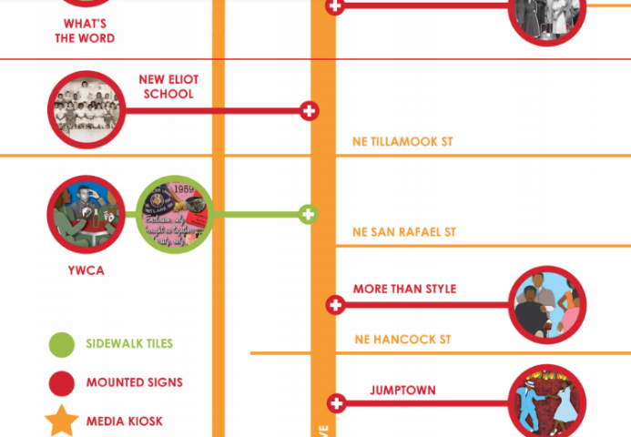
Home to Portland’s largest Black community for most of the 20th century, Williams Avenue included a concentration of thriving and active community institutions. Only a handful of these still exist, but their history and the values of the people that built and cherished them live on.
The art installation includes 30 mounted signs and 10 sidewalk tiles on Williams Avenue between NE Broadway and N Killingsworth that represent the history and values of Black Portland. Note: Most of the signage can be seen better when walking from South to North as the mounted signs face South. Some signs were challenging to find, but nearly all could found within ½ a block of the location shown on the map. Learn more about the project or the creators, Cleo Davis and Kayin Talton Davis at the blackwilliamsproject website.
Virtual Walking Tour: Please click on this link to go to the start of the walking tour on Google Earth. This places you at NE Broadway and Williams Ave, the very southern point of the walking tour, near the “Jumptown” mounted sign at the end of the second page of the linked map. Here is a PDF slideshow of the mounted signs and sidewalk tiles that make up the walking tour.
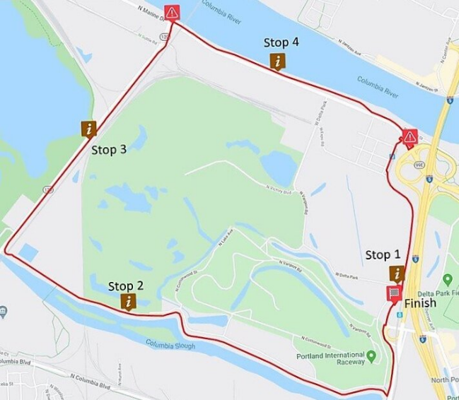
- Vanport History Bike Ride
The memory of Vanport is fading in the minds of many Portlanders. Some people have heard of Vanport but fewer know its history and how the events of 30 May 1948 continue to shape Portland to this day. This is a self guided history bike tour of Vanport beginning and ending at Delta Park/Vanport (yellow line) MAX station. The route is approximately 5.5 Miles and can be found here: Vanport History Route. Click this link for descriptions and videos to play along the route.
Bikes can be rented from Outdoor Pursuits for free. Check the Outdoor Pursuits website, contact Outdoor Pursuits at 503-943-8748, or email libby@up.edu for rental information.
- Portland Murals
PDX Street Art and Murals - Exploring Portland’s street art scene just got easier with the publication of new walking, biking and all-city maps by the Portland Street Art Alliance. This link includes three street art maps of Portland: a walking map of the Alberta Arts District, a biking map of the Central Eastside Industrial District, and an all-city highlights map. Portland street art is always changing, and these maps are a starting point to encourage the street art curious. Who is included in the art you discover and who is left out? The Alberta Arts District is especially relevant to SEE Portland as it is historically home to a large Black community but has a more recent history of gentrification.
Here are a few additional murals you may want to look for:
- Women Making History in Portland – 2335 North Clark Avenue
- Urban League of Portland – 10 N. Russell Avenue
- Invent the Future – 3920 N Kerby Ave
- Black United Fund building featuring significant Black women such as Angela Davis, Coretta Scott King and Maya Angelou – 2828 NE Albert St.
- Fence mural in Humboldt neighborhood – corner of N Haight Ave and Going St (look along the Blue house)
- Now is the Time, the Time in Now – Martin Luther King Jr. – at the corner of NE Shaver and MLK JR Boulevard

Podcasts and Interviews:
- Young Black people share their experiences growing up in Portland - from Think Out Loud, October 30, 2020 (51 minutes)
Racial justice protests have continued in Portland for five months, and the 2020 election is just around the corner. We sit down with two young Black men and a teenager to hear about their experiences growing up in Portland and how they are thinking about this historical moment. Jamartae Brown teaches in the Brothers Reflecting Brotherhood program at Self Enhancement Inc. and is a paraeducator for special education students in Portland Public Schools. Jalen Ladd is a junior project manager at Thesis. And Mekhi Gardner is a seventh grader at Faubion School.
- Mitchell Jackson – from Think Out Loud, February 14, 2020 (51 minutes)
Mitchell Jackson’s new book, “Survival Math,” is by and about a man trying hard to make sense of where he came from and how that place formed him. Most simply, it’s a memoir about his life growing up in Northeast Portland among pimps and drug dealers, about how he survived, and eventually thrived, becoming a celebrated writer and a professor at NYU. The book is also woven through with history, criminology, sociology and mythology. But it’s much more than just a personal memoir. Mitchell gives voice to other men in his life: a dozen family members, each of whom answered the same question: “What’s the toughest thing you’ve survived?”
In this episode, Jackson walks through his old NE Portland neighborhood, discussing his book while exploring the transformation and gentrification of his neighborhood.
- Uprising: A Guide From Portland – 10 episodes, 40-65 minutes each
Background and breakdown on 100 days of Portland insurrection, going in to the background, history of the current protests breaking down the struggles, successes and infrastructure that has made the uprising in Portland possible. Writers for this show includes Donovan Smith, who will facilitate our March 13th Main Event.
- Black on the Bluff – 4 episodes, 30-55 minutes each
Hosted by the University of Portland’s Black Student Union, the club members discuss topics such as becoming aware of race, discussing the uses of “Black” and “African-American”, and Black femininity, in honest, thoughtful and engaging conversations.
- It Did Happen Here – 11 episodes, 18-45 minutes
It Did Happen Here is an independently produced podcast that documents the fight against Portland, OR based racist white skinheads in the 1980s and 90s after the murder of Mulugeta Seraw. This features interviews with many people who worked together in those days and reveal the unlikely collaboration between groups of immigrants, civil rights activists, militant youth and queer organizers who came together to successfully confront the neo-nazi violence and right wing organizing in the Rose City.
- Five years after its passage, how is the Portland Preference Housing Policy working? - from Think Out Loud, January 4, 2021 (25 minutes)
In 2015, the City of Portland passed an affordable housing strategy that was the first of its kind in the nation: It would give preference for housing and home loans to those who'd been displaced from historically Black and now gentrifying neighborhoods in North and Northeast Portland. We check in on the effects of the policy with Leslie Goodlow, the equity business operations manager for the Portland Housing Bureau. And we hear from Gaelan Andrade Booker, who bought his house last year with help from the policy, and Portland Housing Center home buying specialist Shalonda Menefee, who helps people purchase homes using assistance from the policy.
- Beyond the Protests from Beat Check with the Oregonian, June 8, 2020 (37 minutes)
Portland is now in its second week of massive demonstrations and protests – with thousands of people in the street every night demanding racial justice in the name of George Floyd, and Breonna Taylor and so many other black Americans killed by police.
On this episode, you’ll hear from six community leaders -- some who have been active in Portland for decades, and others who are among the newest generation fighting for civil rights. They spoke about how they are doing, what they’re feeling, how racism has affected their lives and whether they have hope that true change is coming.
Featuring: Markayla Ballard, 21, from Tualatin; Fahim Acuay, 39, from Portland; Avel Gordly, 73, from Portland; Ernest Warren Jr., 60, from Portland; Laquida Landford, 43, from Portland; Stephen Green, 42, from Portland.
- Black Futures Farm interview – July 21, 2020 (8 minutes)
“Black Futures Farm is working to restore Black people to the land,” said Malcolm Shabazz Hoover. As the co-founder and co-director of the Black Futures Farm, Hoover runs the community farm with his partner and wife Mirabai Collins and a staff of volunteers. The Black Futures Farm is part of a coalition of Black and African-identifying food producers that, along with educators, community builders and advocates, are working towards a goal of Black food sovereignty. Listen to Hoover speak about the farm and read more here.

Documentaries and Videos:
- Why Aren’t There More Black People in Oregon: A Hidden History – Walidah Imarisha:
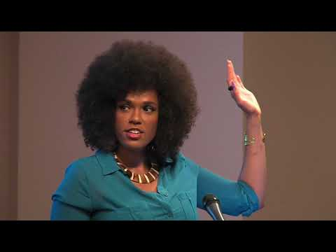
Have you ever wondered why the Black population in Oregon is so small? Oregon has a history not only of Black exclusion and discrimination, but also of a vibrant Black culture that helped sustain many communities throughout the state—a history that is not taught in schools. Author, educator and UP’s 2020 MLK Day On speaker Walidah Imarisha will lead participants through an interactive timeline of Black history in Oregon that speaks to the history of race, identity, and power in this state and the nation. Participants will discuss how history, politics, and culture have shaped—and will continue to shape—the landscape not only for Black Oregonians but all Oregonians. Thomas Robinson will share a photo essay on the impact of the policies and decisions that have impacted Black Portlanders in North and Northeast Portland.
You can view this on YouTube here or with the embedded video above.
A shorter version of the timeline, presented by Walidah Imarisha:

- Taylor Stewart – 2021 University of Portland MLK Day On keynote (total event is 1 hour 47 minutes, Taylor’s keynote begins at 40 minutes)
Taylor Stewart, alumnus class of ’18. Mr. Stewart's work confronts the legacy of racism in Oregon by marking the site of Alonzo Tucker’s lynching in Coos Bay, OR. Mr. Stewart’s efforts serve as a starting point for informing, educating, and inspiring dialogue about race and white supremacy in our community.
Now a special 30 minute Q&A session between Taylor and Tshombé Brown is available to view at the link above.
- Vanport – Oregon Experience documentary (51 minutes)
During the early 1940s, Vanport, Oregon was the second largest city in the state. But on a Sunday afternoon in May 1948, it disappeared completely - destroyed by a catastrophic flood.

- Priced Out: Portland’s History of Segregation and Redlining. Here is the link to the documentary, with the trailer shown below.
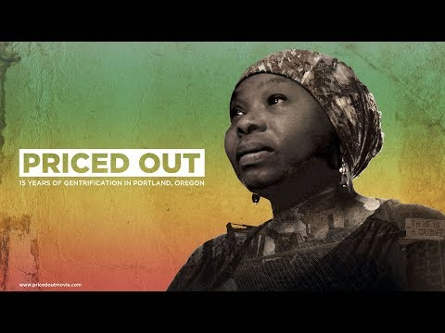

- Lift Ev’ry Voice – documentary – (1 hour, 22 minutes)
Lift Ev’ry Voice explores Portland’s African American history with a focus on the turbulent 1960s, ’70s and early ’80s. At the time, issues surrounding urban renewal, school desegregation and brittle police relations were exploding both nationally and locally.
Portland Civil Rights: Lift Ev’ry Voice is told largely through the words of men and women who lived through and led the struggles for human rights in Portland, and with archival film and images illustrating these remarkable times.
- Arresting Power documentary – (1 hour, 22 minutes)
Arresting Power: Resisting Police Violence in Portland, Oregon documents the history of conflict between the Portland police and community members throughout the past fifty years. The film features personal stories of resistance told by victims of police misconduct, the families of people who were killed by police, and members of Portland’s reform and abolition movements.
Utilizing meditative footage taken at sites of police violence, experimental filmmaking techniques, and archival newsreel, Arresting Power creates a space for understanding the impacts of police violence and imagining a world without police.

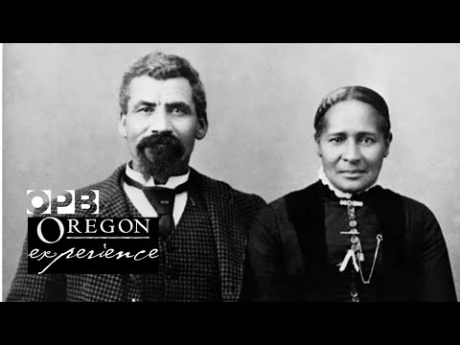
- Oregon’s Black Pioneers – (30 minutes)
Long before Oregon became a state, black people were in the Far West. Some were brought to the region as slaves, but many others arrived as freemen looking for a new life. They opened boarding houses and stores, worked farms and mined for gold. But as more white settlers arrived over the Oregon Trail, the newcomers passed discriminatory laws to keep African Americans out. “Oregon Experience” examines the largely unknown history of Oregon’s black pioneers.

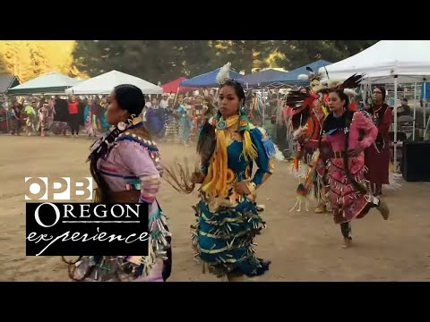
- Broken Treaties – (59 minutes)
For thousands of years, more than 60 Native American tribes lived in Oregon's diverse environmental regions. At least 18 languages were spoken across hundreds of villages. This civilizational fabric became unraveled in just a few short decades upon contact with white settlers in the 19th century. In this ""Oregon Experience"" documentary, Native Oregonians reflect on what has been lost since and what's next for their tribes.

- Oregon’s Japanese Americans - (65 minutes)
By the 1920s, Oregon had well-established Japanese American communities in Portland and Hood River. Immigrant pioneers managed businesses, thriving farms and orchards with their American-born children. Pearl Harbor changed everything.

- Mitchell Jackson on Amanpour & Co – (16 minutes)
Mitchell Jackson grew up in NE Portland and has published two books, Residue Years, a fictionalized version of his life growing up in Portland, and Survival Math, in which Jackson candidly explores his tumultuous youth. Survival Math takes its name from the calculations Mitchell and his family made to keep safe—to stay alive—in their community, a small black neighborhood in Portland, Oregon blighted by drugs, violence, poverty, and governmental neglect.

- Avel Gordly – (15 minutes)
Avel Gordly lived a life of public service in Oregon, including being the first African-American women elected to the Oregon State Senate in 1996. Hear more from Gordly with the release of her memoir, Remembering the Power of Words, and read more about her story here.
- Turtle Island Storytellers – (5 minutes)
Two stories told by Coos, Lower Umpqua and Siuslaw Storyteller Patty Whereat Phillips (Miluk Coos) about the long winters and about the salmon runs.
- This is the Real Portland - (5 minutes)
The video shared by Donovan Smith during our Kickoff about experiences of Portland and an invitation to take action before a January 6th, 2021 vote. Here is an article that shares some background about that vote.
- Sharita Towne: On 'Black geography' and community-based art in Portland – (9 minutes)
Artist Sharita Towne engages with both place making and displacement activity that has shaped Black communities along the West Coast. In Portland, her work takes many forms: from creating podcast episodes with Jefferson High School students, to screen printing posters and organizing interactive exhibits. Her current project, ""A Black Art Ecology of Portland,"" includes a multigenerational team of Black artists and activates several architectural sites significant to the Black community.
- Urban Removal in Albina, Portland – (6 minutes)
Since 2000, over 10,000 people of color have been displaced from North and Northeast Portland to the outer edges of the city. The area has a long history of such segregation, from the state’s earliest Black Exclusion Laws in the 1840s to aggressive and targeted urban renewal. These divides have been compounded by racist real estate actors, banks that wouldn’t lend, and predatory lenders that eagerly did. Displaced residents and their descendants are demanding action.
- Portland as a Bike Town and Gentrification (5 minutes)
Portland is well known for its eccentric bike culture, and an explosion in cycling has helped the city make impressive progress toward its ambitious climate goals. Today the city is still pushing the envelope, but along the way it is learning important lessons about how these efforts impact its citizens, especially the Black community of Albina.

Theater:
- Where is Home? A digital living newspaper (1 hour – skip to 10:45 for the start of the intro to the play)
Where is Home? A Digital Living Newspaper, inspired by the living newspapers of the depression-era Federal Theatre Project, addresses and exposes historic and current housing inequity in Portland. This performance piece is conceived and built collaboratively by Dr. Lezlie Cross and a team of University of Portland student actors, researchers, stage managers, and designers. Adapting the basic tenets of devised theatre to a digital environment and performed in November 2020, this innovative documentary production will guide audiences through the issues, a discussion and, we hope, action in their own communities.

